Library Management System
Practical 7 – Boundary Value Analysis (BVA) & Equivalence Partitioning (EP)
Student Name: Meshwa Prajapati| Testing Techniques: BVA & EP

1. Student Details
Module Name | Library Management System
Practical Number | 7
Student Name | Meshwa Prajapati
Testing Technique | Boundary Value Analysis (BVA) & Equivalence Partitioning (EP)

2. Validation Requirements
Username | 5 – 15 characters
Password | 8 – 16 characters

3. Username – BVA Test Cases
TC ID | Input | Expected Result
BVA01 | 4 characters | Invalid
BVA02 | 5 characters | Valid
BVA03 | 6 characters | Valid
BVA04 | 14 characters | Valid
BVA05 | 15 characters | Valid
BVA06 | 16 characters | Invalid

4. Username – EP Test Cases
TC ID | Equivalence Class | Input | Expected Result
EP01 | Below 5 characters | 4 characters | Invalid
EP02 | 5–15 characters | 10 characters | Valid
EP03 | Above 15 characters | 16 characters | Invalid

5. Password – BVA Test Cases
TC ID | Input | Expected Result
BVA07 | 7 characters | Invalid
BVA08 | 8 characters | Valid
BVA09 | 9 characters | Valid
BVA10 | 15 characters | Valid
BVA11 | 16 characters | Valid
BVA12 | 17 characters | Invalid

6. Password – EP Test Cases
TC ID | Equivalence Class | Input | Expected Result
EP04 | Below 8 characters | 7 characters | Invalid
EP05 | 8–16 characters | 10 characters | Valid
EP06 | Above 16 characters | 17 characters | Invalid

7. Test Execution

Test Case: BVA01
Input: 4-character username
Execution: Open Library Management System login page → Enter username with 4 characters → Enter password → Click Login
Screenshot: [Insert Screenshot Here]
Actual Result: Validation message was displayed because the username was less than 5 characters.
Status: Pass / Fail

Test Case: BVA02
Input: 5-character username
Execution: Open Library Management System login page → Enter username with 5 characters → Enter password → Click Login
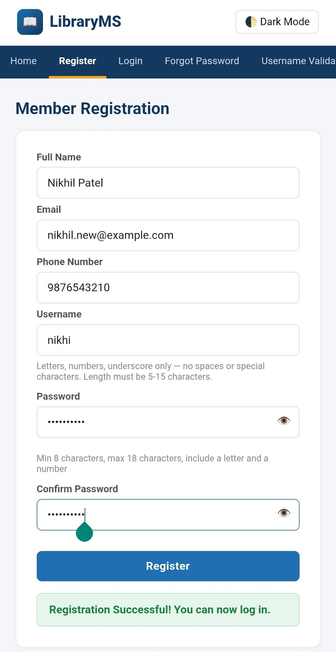

Actual Result: Login was accepted because the username length was exactly 5 characters.

Test Case: BVA03
Input: 6-character username
Execution: Open Library Management System login page → Enter username with 6 characters → Enter password → Click Login
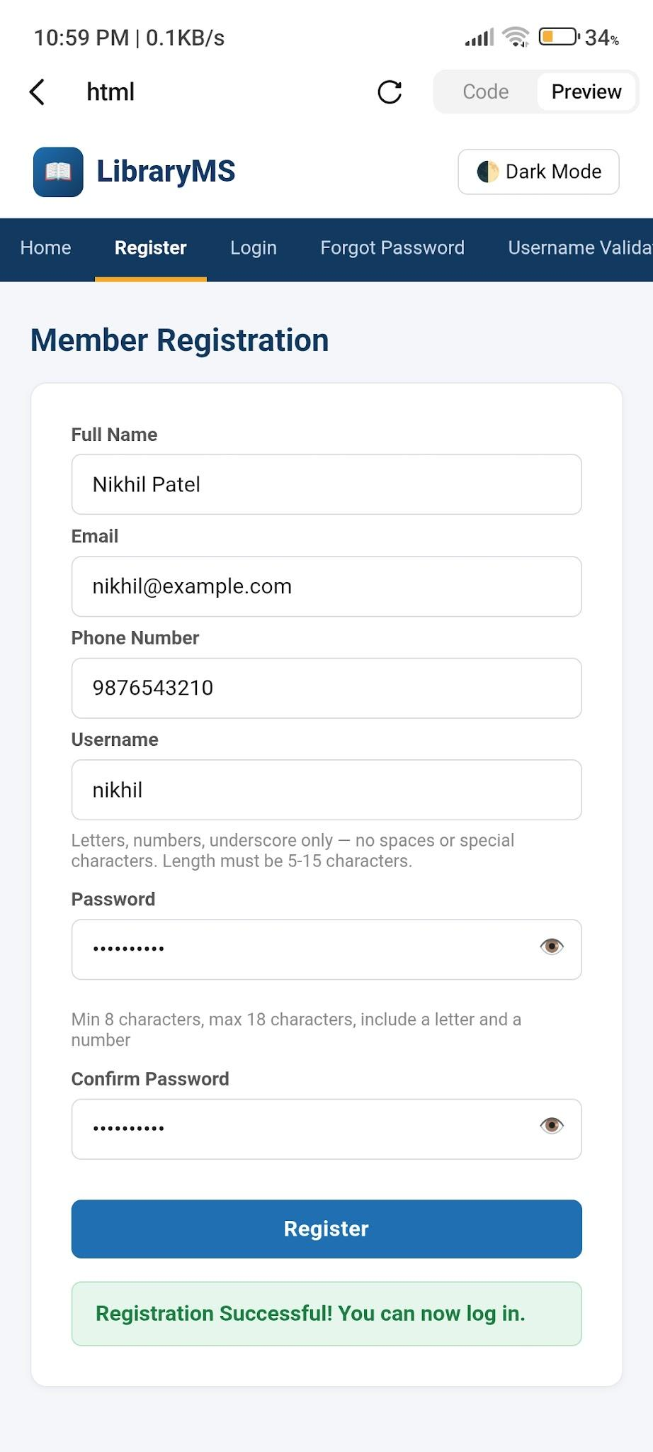
Actual Result: Login was accepted because the username length was within the valid range.
Status: Pass / Fail

Test Case: BVA04
Input: 14-character username
Execution: Open Library Management System login page → Enter username with 14 characters → Enter password → Click Login
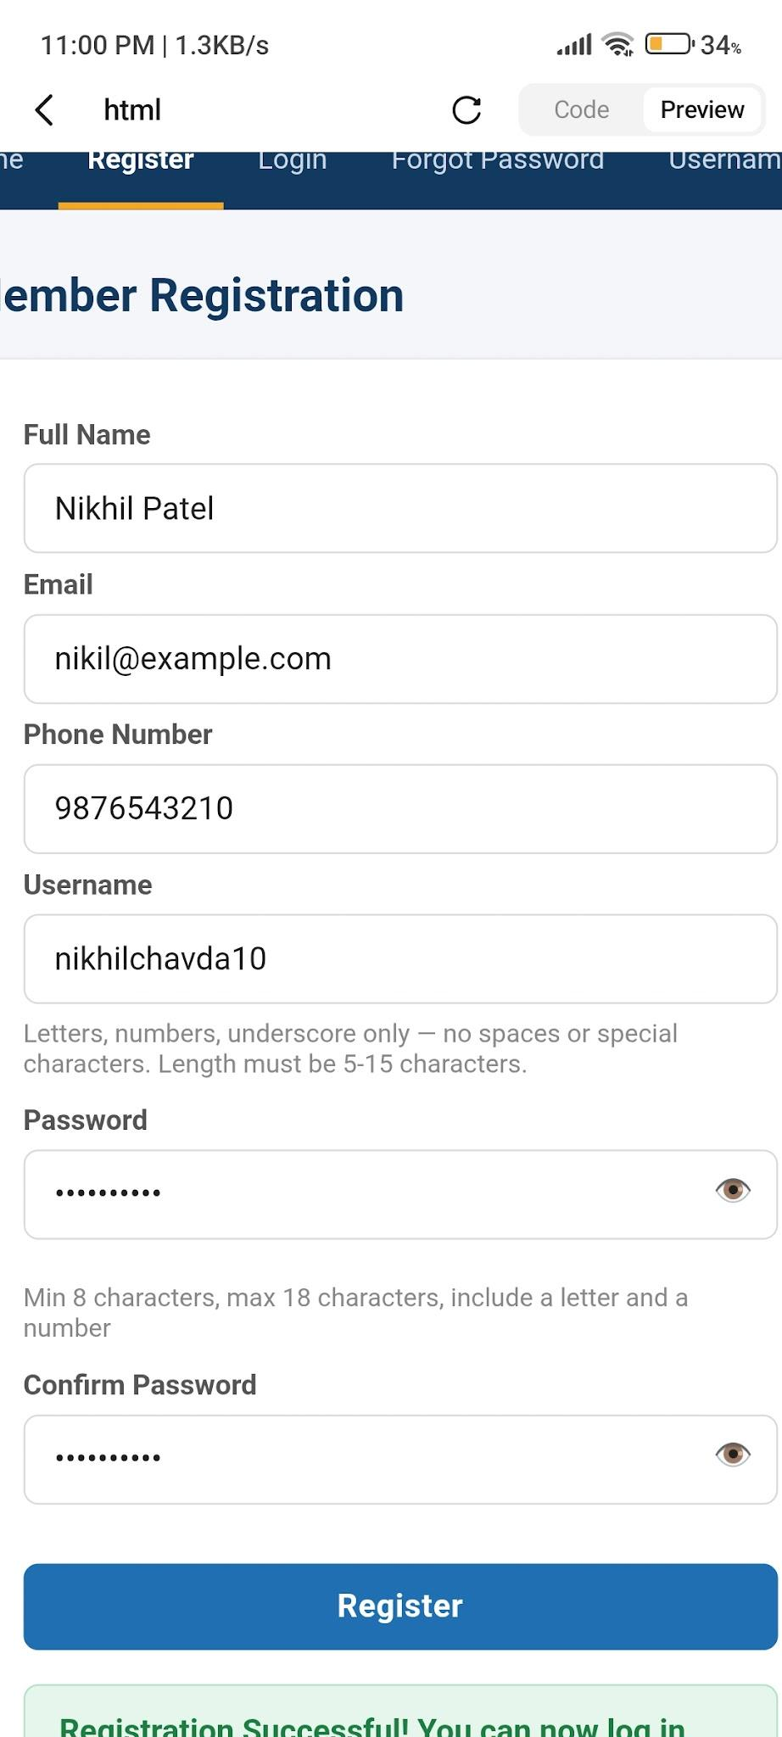
Actual Result: Login was accepted because the username length was within the valid range.
Status: Pass / Fail

Test Case: BVA05
Input: 15-character username
Execution: Open Library Management System login page → Enter username with 15 characters → Enter password → Click Login
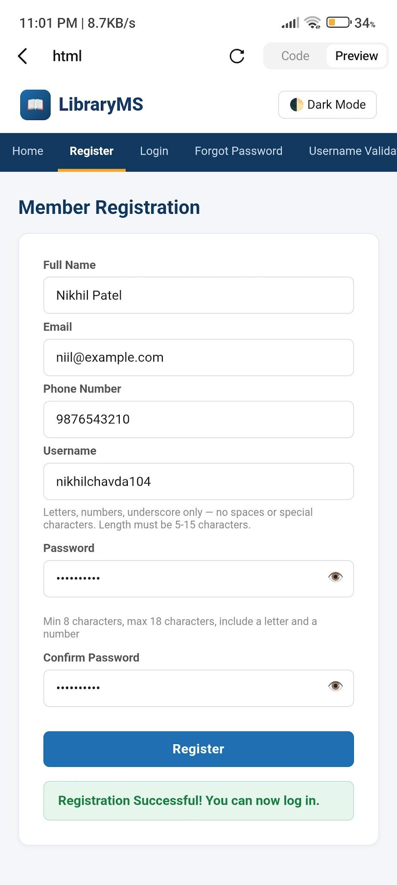
Actual Result: Login was accepted because the username length was exactly 15 characters.
Status: Pass / Fail

Test Case: BVA06
Input: 16-character username
Execution: Open Library Management System login page → Enter username with 16 characters → Enter password → Click Login
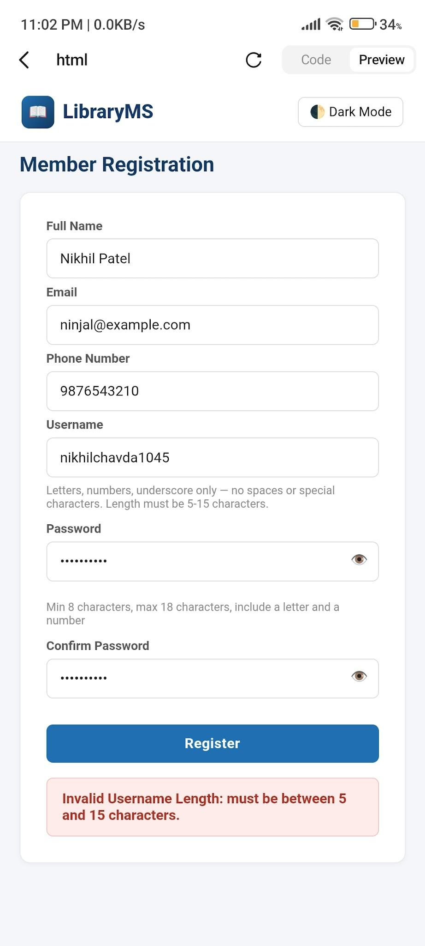
Actual Result: Validation message was displayed because the username exceeded 15 characters.
Status: Pass / Fail

Test Case: EP01
Input: 4-character username (Below 5)
Execution: Open Library Management System login page → Enter username with 4 characters → Enter password → Click Login
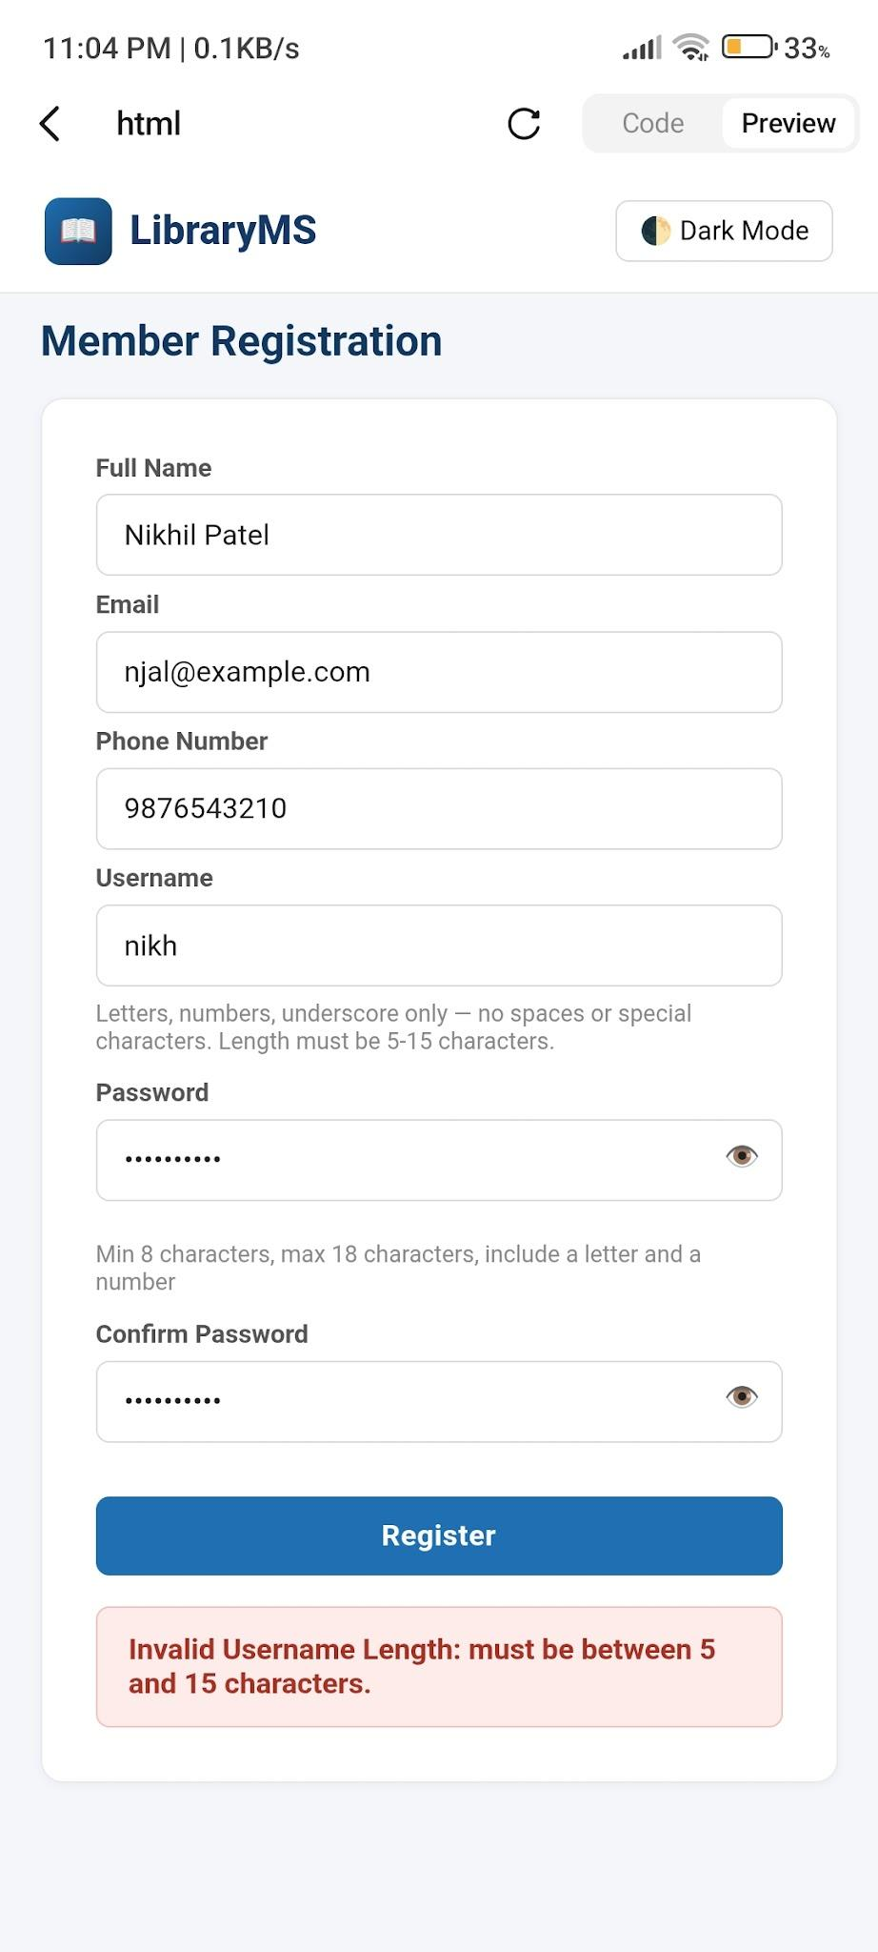
Actual Result: Validation message was displayed because the username fell in the invalid equivalence class (below 5).
Status: Pass / Fail

Test Case: EP02
Input: 10-character username (5–15)
Execution: Open Library Management System login page → Enter username with 10 characters → Enter password → Click Login
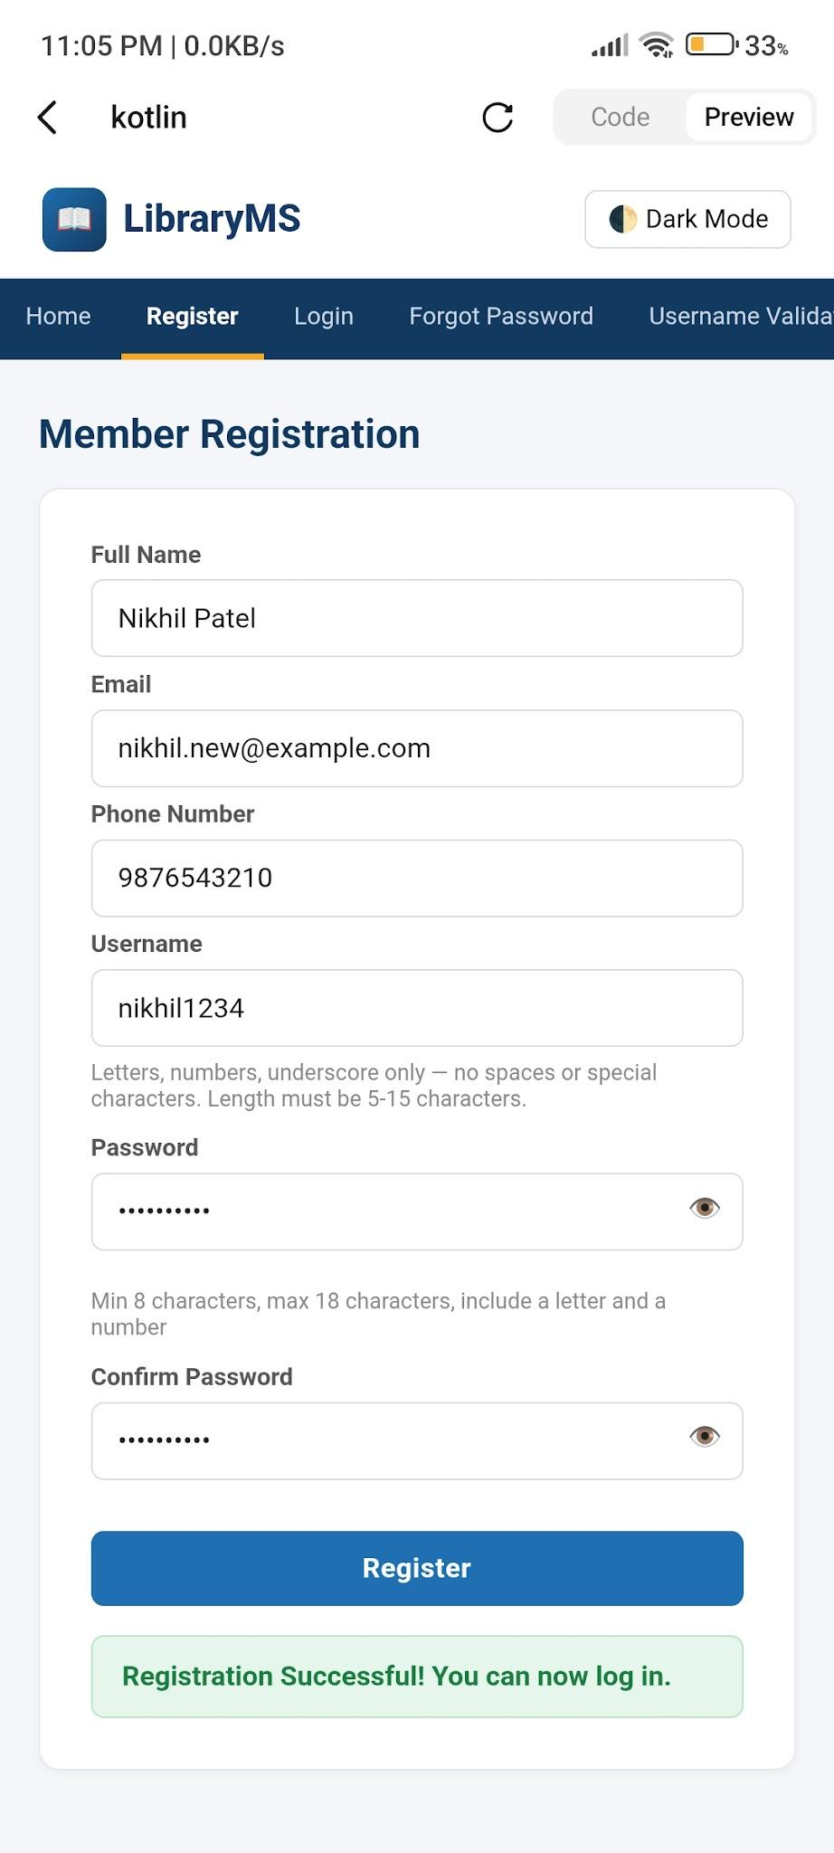
Actual Result: Login was accepted because the username fell in the valid equivalence class (5–15).
Status: Pass / Fail

Test Case: EP03
Input: 16-character username (Above 15)
Execution: Open Library Management System login page → Enter username with 16 characters → Enter password → Click Login
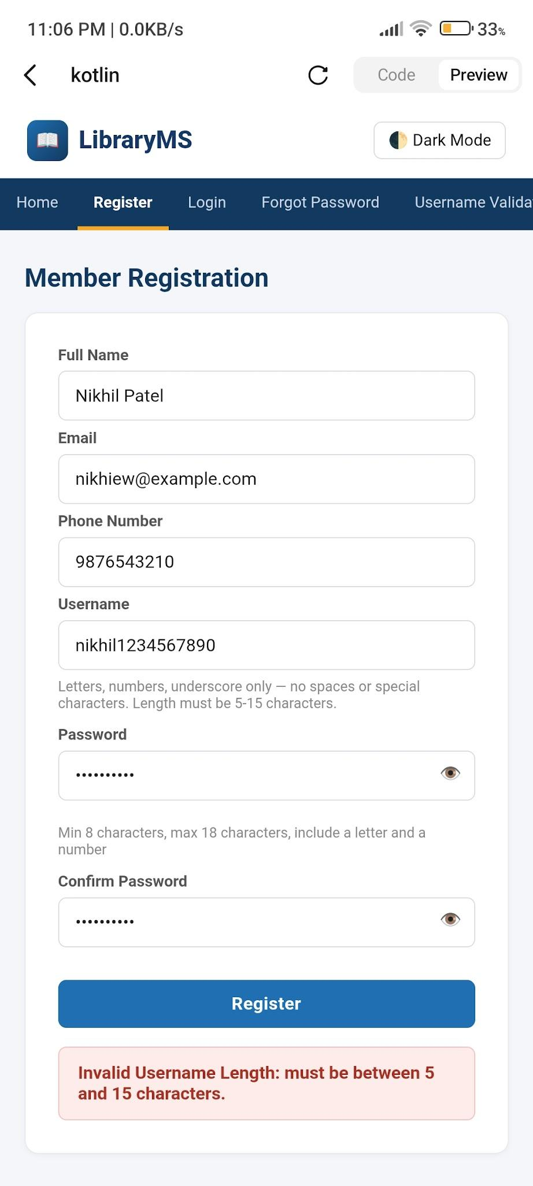
Actual Result: Validation message was displayed because the username fell in the invalid equivalence class (above 15).
Status: Pass / Fail

Test Case: BVA07
Input: 7-character password
Execution: Open Library Management System login page → Enter valid username → Enter password with 7 characters → Click Login
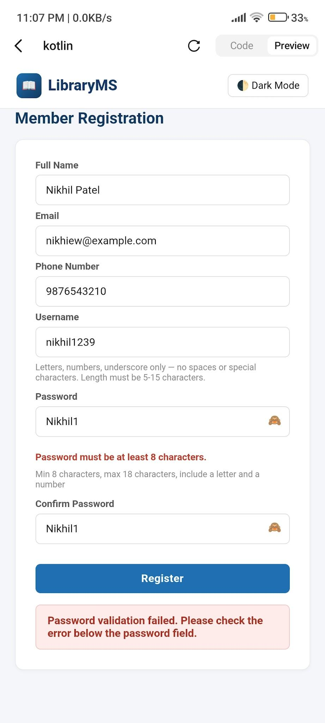
Actual Result: Validation message was displayed because the password was less than 8 characters.
Status: Pass / Fail

Test Case: BVA08
Input: 8-character password
Execution: Open Library Management System login page → Enter valid username → Enter password with 8 characters → Click Login
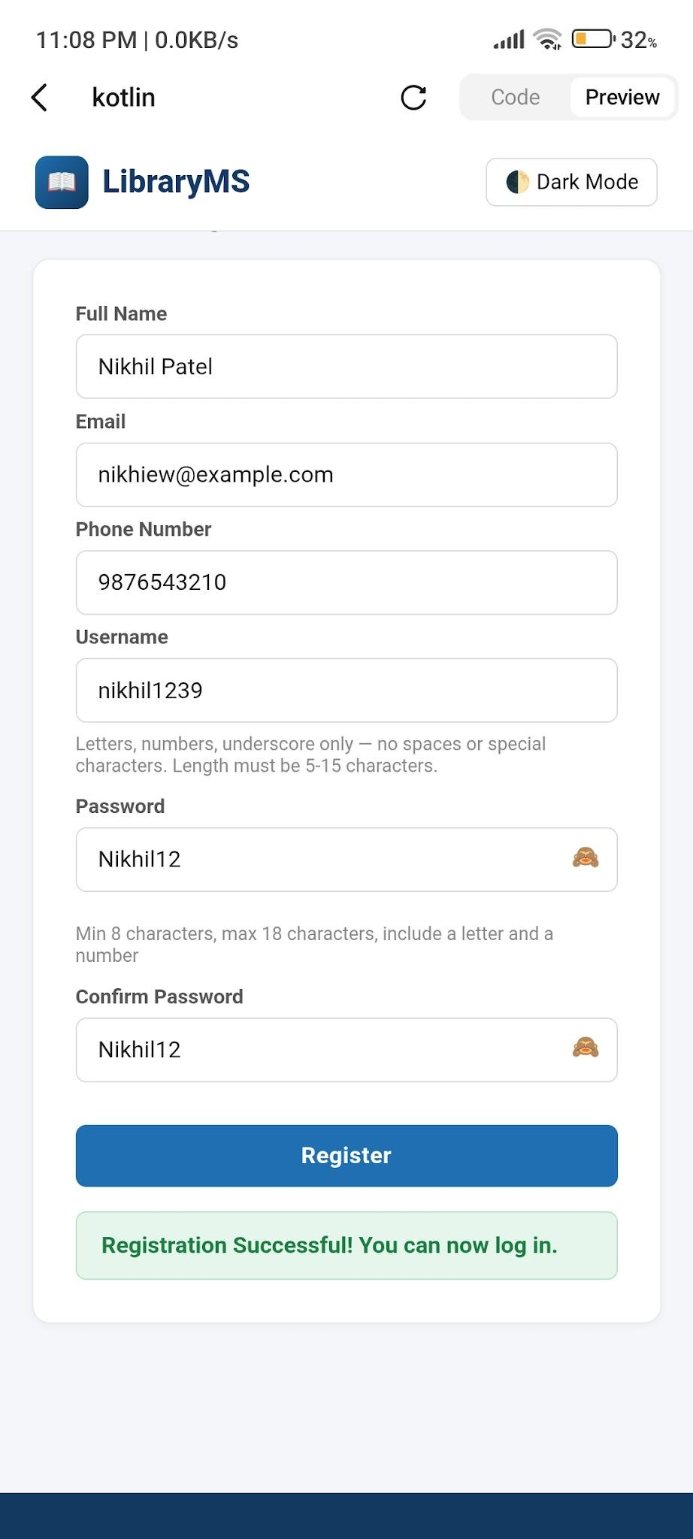
Actual Result: Login was accepted because the password length was exactly 8 characters.
Status: Pass / Fail

Test Case: BVA09
Input: 9-character password
Execution: Open Library Management System login page → Enter valid username → Enter password with 9 characters → Click Login
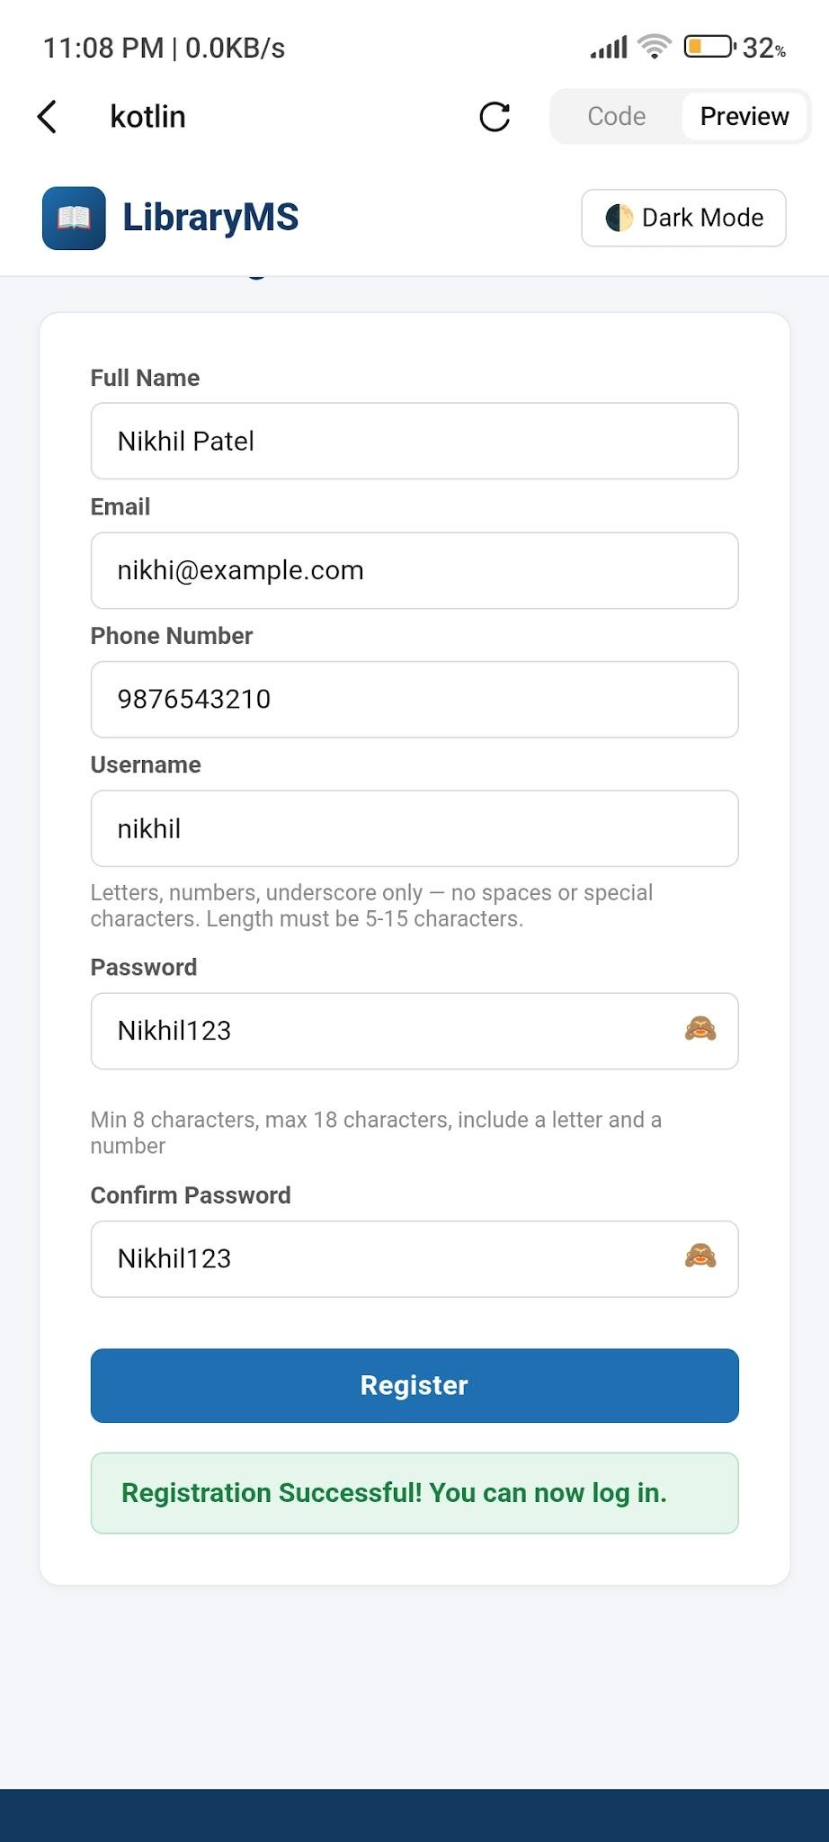
Actual Result: Login was accepted because the password length was within the valid range.
Status: Pass / Fail

Test Case: BVA10
Input: 15-character password
Execution: Open Library Management System login page → Enter valid username → Enter password with 15 characters → Click Login
Screenshot: 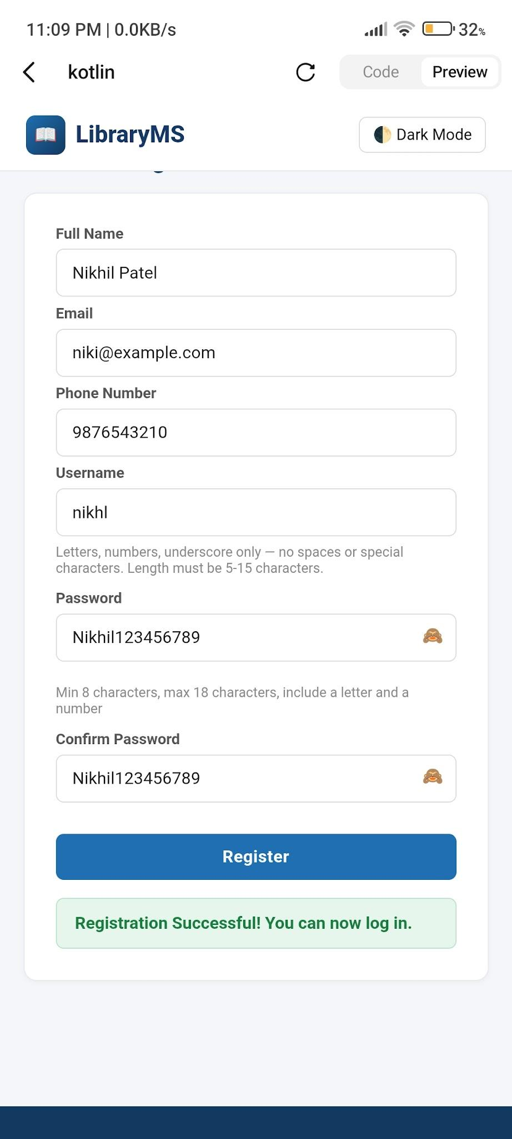
Actual Result: Login was accepted because the password length was within the valid range.
Status: Pass / Fail

Test Case: BVA11
Input: 16-character password
Execution: Open Library Management System login page → Enter valid username → Enter password with 16 characters → Click Login
Screenshot: 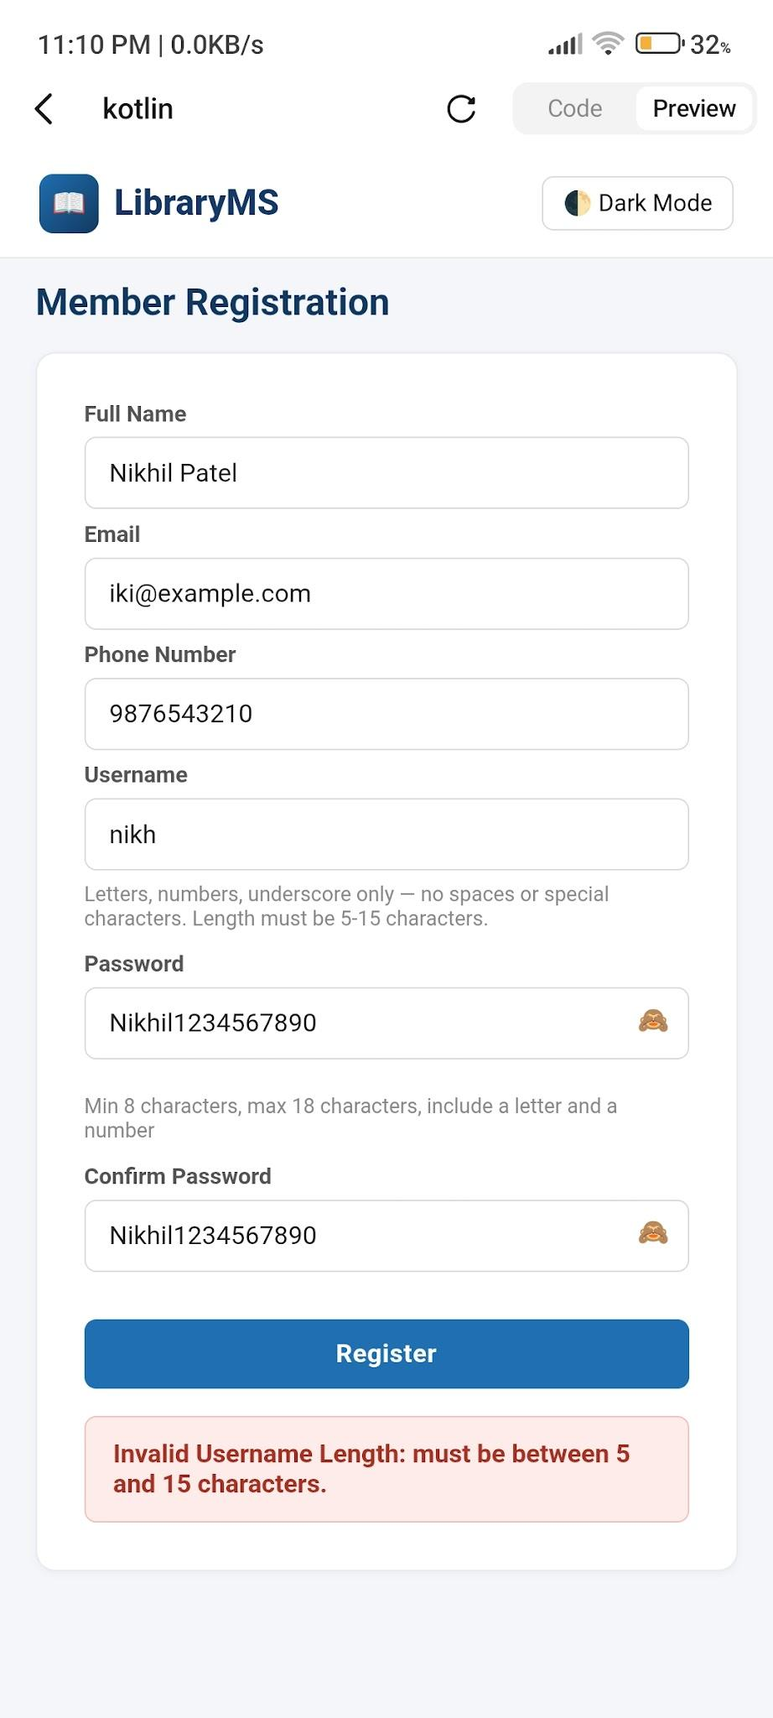
Actual Result: Login was accepted because the password length was exactly 16 characters.
Status: Pass / Fail

Test Case: EP04
Input: 7-character password (Below 8)
Execution: Open Library Management System login page → Enter valid username → Enter password with 7 characters → Click Login
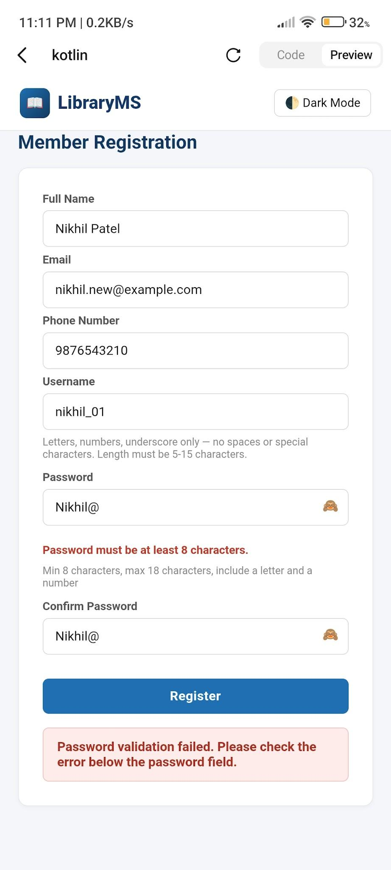
Actual Result: Validation message was displayed because the password fell in the invalid equivalence class (below 8).
Status: Pass / Fail

Test Case: EP05
Input: 10-character password (8–16)
Execution: Open Library Management System login page → Enter valid username → Enter password with 10 characters → Click Login
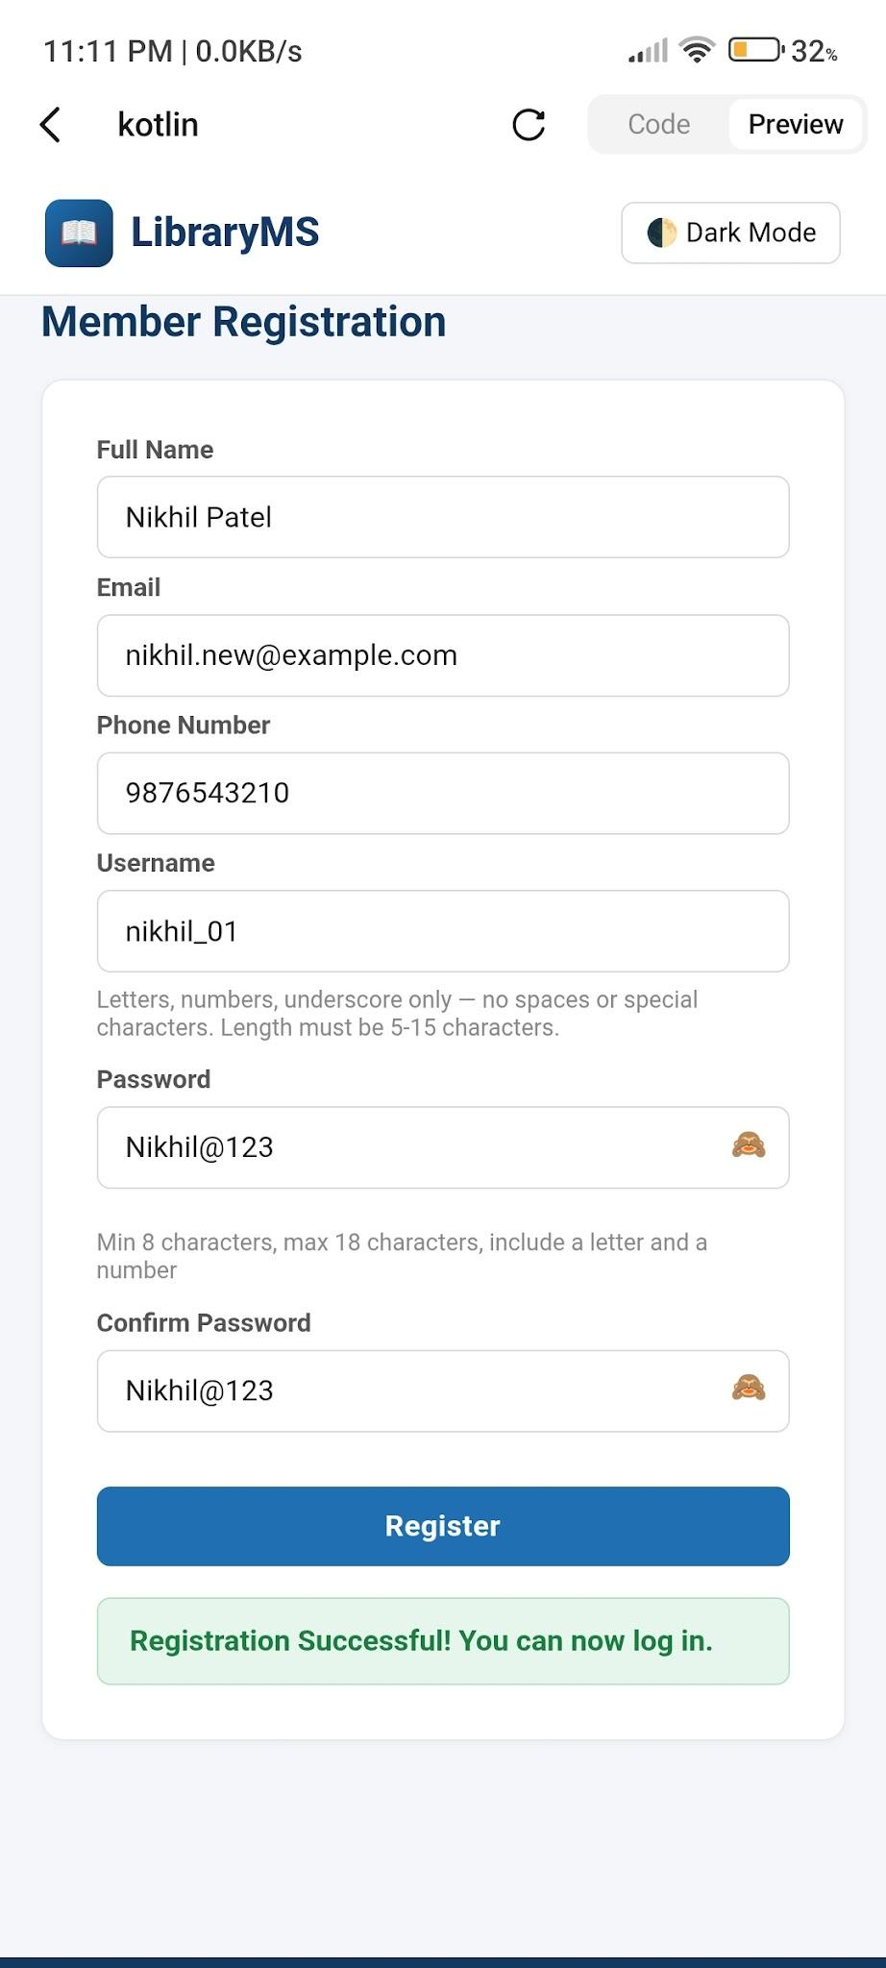
Actual Result: Login was accepted because the password fell in the valid equivalence class (8–16).
Status: Pass / Fail

Test Case: EP06
Input: 17-character password (Above 16)
Execution: Open Library Management System login page → Enter valid username → Enter password with 17 characters → Click Login
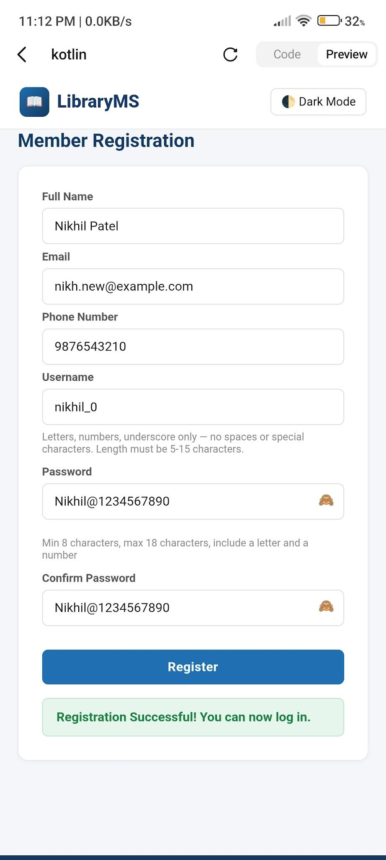
Actual Result: Validation message was displayed because the password fell in the invalid equivalence class (above 16).
Status: Pass / Fail

— End of Practical 7 Report —

